**PROJECT REPORT**

## **1.INTRODUCTION**

## 

## **1.1 Overview**

## Our Project is about how we manage our Vehicles and Drivers.

## To manage our Vehicle’s through our app we need some data of customer’s

## Vehicles where a customer Details are stored in order to choose cars, bikes and

## Commercial vehicles for travel with in city. The data which is store here is

## Further used to remind them if any offers are provided during the seasons and

## any updates regarding vehicles are sent to them in the form of messages and

## mails.

## **1.2 Purpose**

## The purpose of this Vehicle Management app is to Manage the data of vehicles and drivers to provide in a Simplified usage to the customers. Not only the data that states about the simple data of vehicles but in a detailed manner to the customers about the vehicle. The Simplified data of Drivers provide the detail to the customer on time with latest updates.

## **2. PROBLEM DEFINITION & DESIGN THINKING**

## **2.1 Empathy Map**

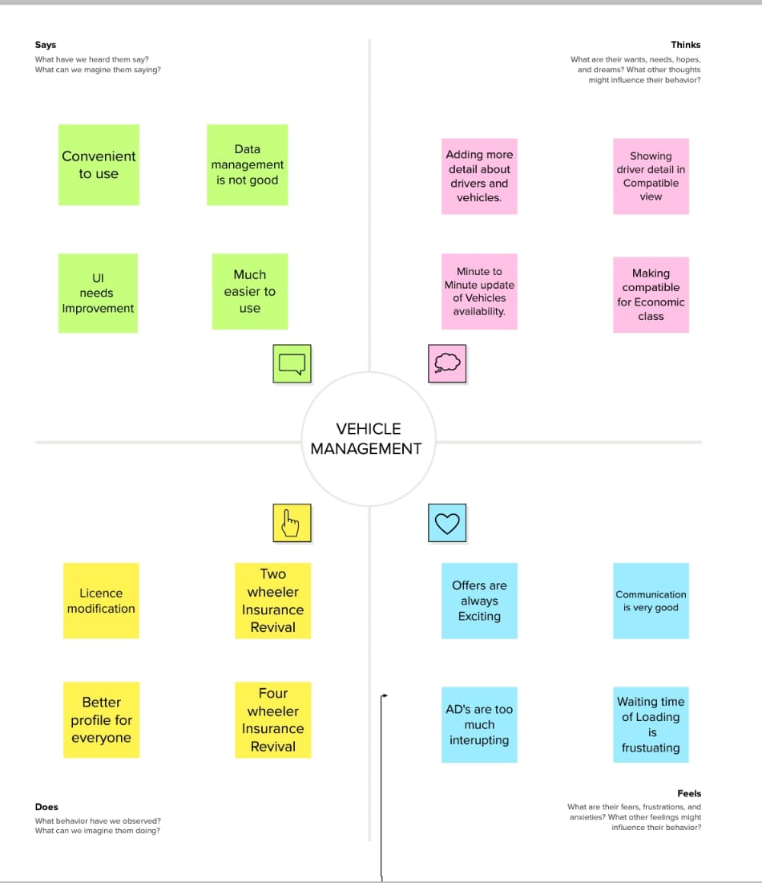

2.2 Ideation & Brainstorming Map

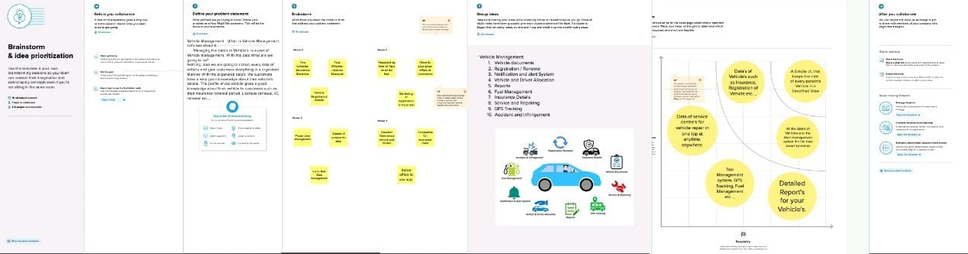

3. RESULT

3.1 Data Model

|  |  |
| --- | --- |
| OBJECT NAME | FIELDS IN THE OBJECT |
| VEHICLE | |  |  | | --- | --- | | Field Name | Data type | | Customer Name | Text | | Customer Mobile No | Number | | Vehicle Type  (i)2 wheeler  (ii)4 wheeler | Picklist | | 2WHEELERS | Picklist | | 4WHEELERS | Picklist | | Vehicle Name | Text | | Vehicle No | Text | | Chassis No | Text | | Colour | Text | | Vehicle Includes | Multi Picklist | | Condition | Picklist | | Mileage | Text | | Seats | Number | | Start Date | Date/Time | | End Date | Date/Time | | Opportunity | Lookup | | Body type | Text | |

|  |  |
| --- | --- |
| **OBJECT NAME** | **FIELDS IN THE OBJECT** |
| Driver | |  |  | | --- | --- | | **Field** | **Data Type** | | Driver Name | Text | | License No | Text | | Mobile No | Number | | Fair Per Hour | Text | | Vehicle | Lookup | |

3.2 Activity Screen shots

1. Home Page of Salesforce Account

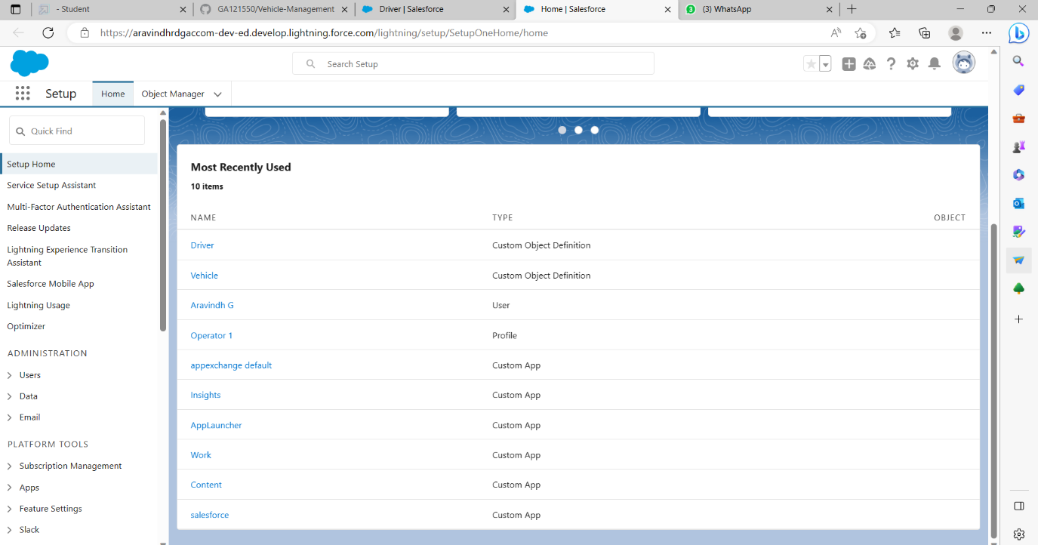

1. Vehicle – Fields & Relationships

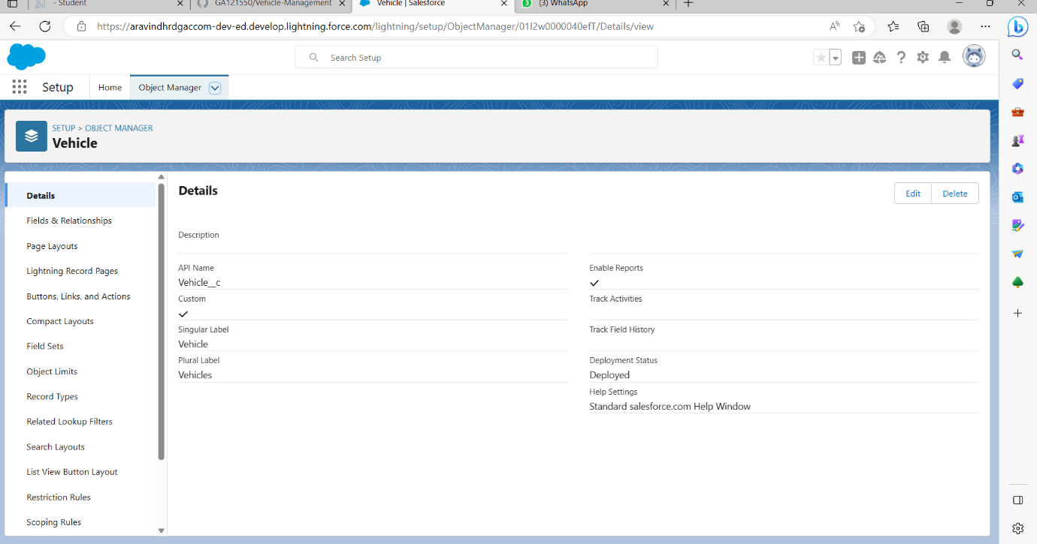

1. Driver - Fields & Relationships

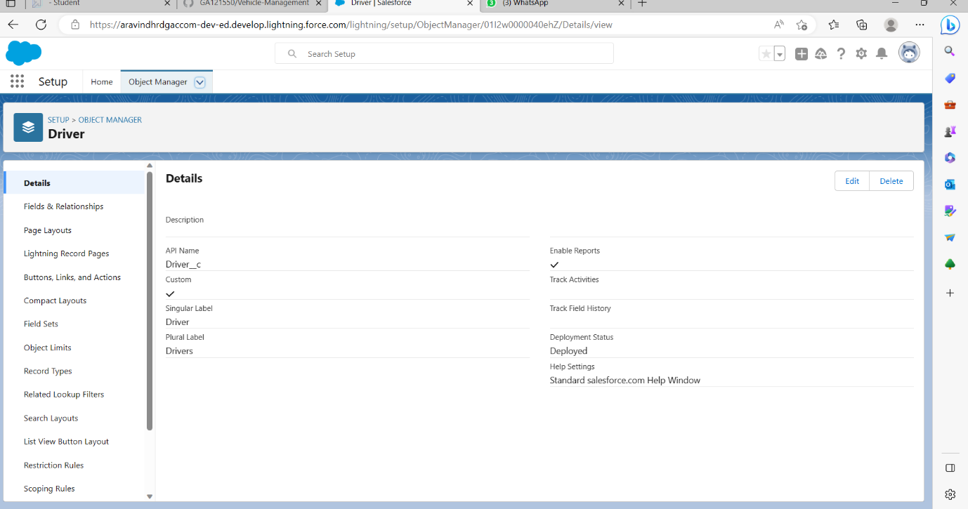

1. Lightning App



1. Profile and Roles Setup

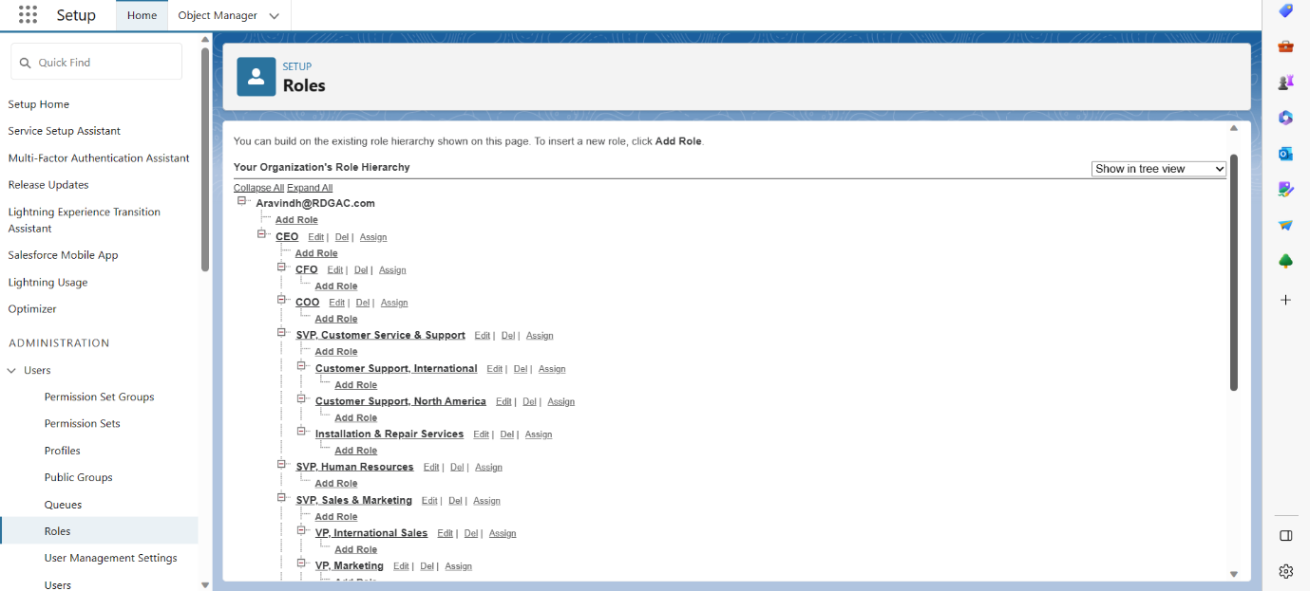

1. Users

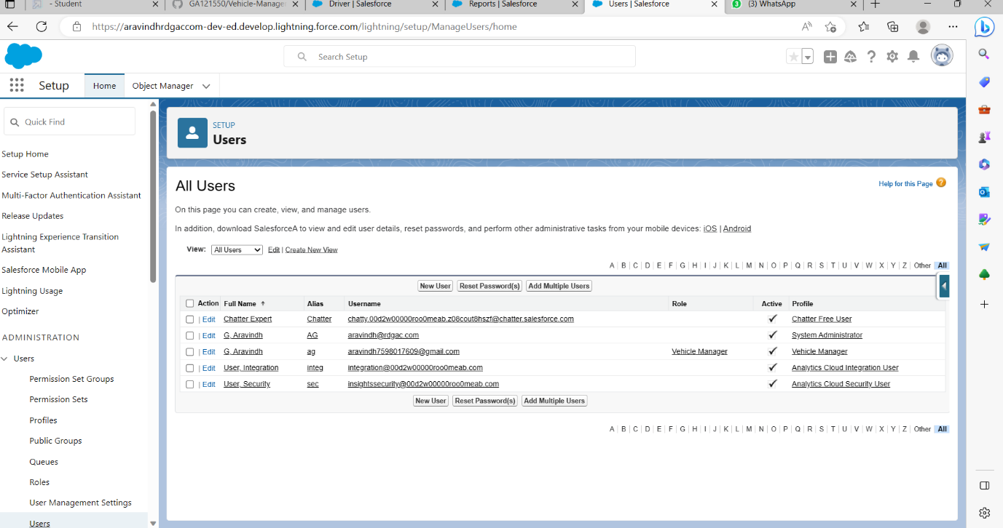

1. Reports and Dashboards

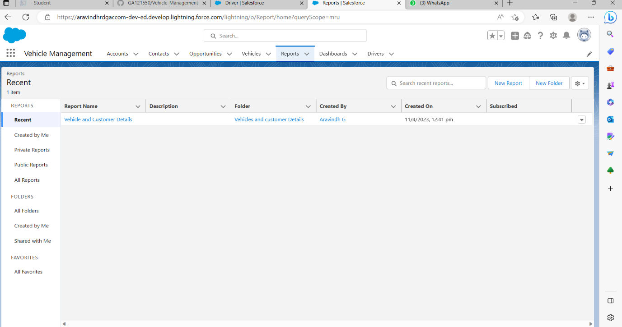

1. Git Hub Account Home Page

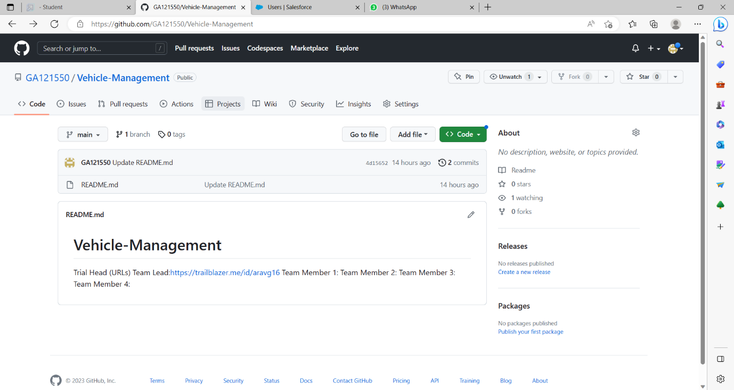

**4. TRIALHEAD PROFILE PUBLIC URL**

Team Leader: https://trailblazer.me/id/sujim14

Team Member 1: https://trailblazer.me/id/suji2

Team Member 2: https://trailblazer.me/id/pandr172

Team Member 3: https://trailblazer.me/id/priya2682

**5. ADVANTAGES AND DISADVANTAGES**

|  |  |
| --- | --- |
| **ADVANTAGES** | **DISADVANTAGES** |
| Easier to access all data at a Single Simplified View | Collection of all data Invades the Privacy of customers |
| Unique customer Id | Confuses the usual way of Customer Name |
| Driver’s Availability will be shown up to time | Driver’s details is not enough to trust the driver |
| Verification of Data as per government Rules | May happen the Submission of Fake documents |
| Condition of Vehicles | Trust on the Condition of Vehicle and Driver |

**6.APPLICATIONS**

The Vehicle Management app can be use to monitor the car, Bus, Lorry and other heavy Vehicles travelling on road. Not only the Vehicle also the availability of drivers to these vehicles can be monitored through this app.It can be used to alert the customer to remind them about their Vehicle and their journey.

**7. CONCLUSION**

Vehicle Management app can be use to Monitor the Activity of drivers on the Road as well as The Vehicles such as Motorcycle, Car, Bus, Lorry, Truck and other Heavy Vehicles.

**8.FUTURE SCOPE**

In Future We additionally add by tracking and Monitoring the Vehicles and Drivers through this app. Not only Tracking the Vehicles and Drivers we can also Monitor the Night driving Vehicles.